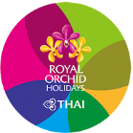

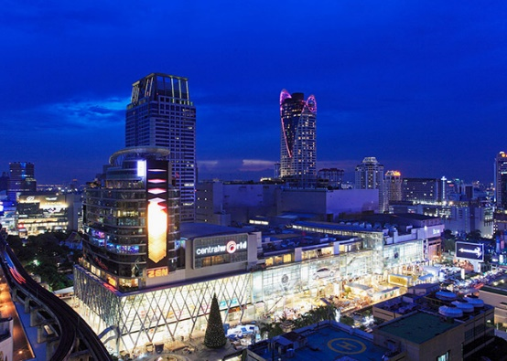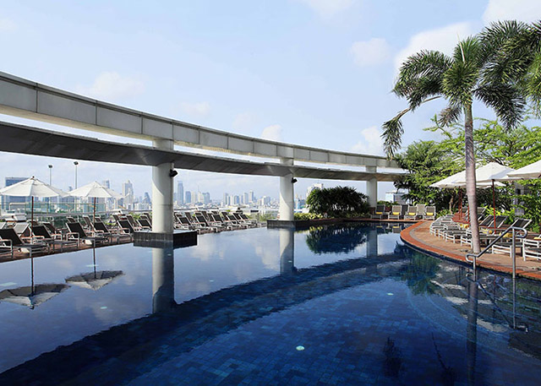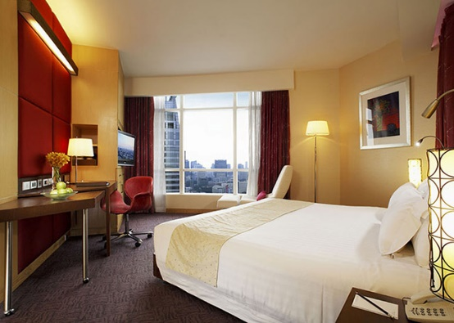

**Centara Grand Central World**

**Bangkok 3 Days 2 Nights**

[**http://www.centarahotelsresorts.com/cgcw/cgcw_default.asp**](http://www.centarahotelsresorts.com/cgcw/cgcw_default.asp)

**Validity from 01/5 - 31/10/2020**

**AC200/EN5.0**  Issued:12/03/2020

**Promotion Offer for stay 01May – 31Jul**

**Package included: Air ticket + Hotel accommodation with daily breakfast**

|  |  |  |  |  |  |  |  |  |  |  |  |
| --- | --- | --- | --- | --- | --- | --- | --- | --- | --- | --- | --- |
| **Room Category** | **Hotel**  **Staying period** | **Package price**  **<**HK$/per person 港幣價目/每位計> | | | | | | **Extension night with Breakfast** | | | |
| **Adult** | | | **Child** | | | <HK$/per person 港幣價目/每位計> | | | |
| **Twin** | **Single** | **Ex. Bed** | **Twin** | **Ex. Bed** | **No Bed** | **Twin** | **Single** | **Ex. Bed** | **No Bed** |
| **Superior World**  Double bed ~ 2 persons | **01/5-31/7/20** | **2,790** | **3,790** | **N/A** | **2,490** | **N/A** | **N/A** | *558* | *1,116* | N/A | N/A |
| 01/8 – 30/9/20 | **3,090** | **4,450** | **2,790** | *725* | *1,449* |
| 01-31/10/20 | **3,250** | **4,750** | **2,950** | *801* | *1,602* |
| **Deluxe World**  3 Adults / 2 Adults + 1 Child | **01/5-31/7/20** | **2,890** | **3,950** | **2,850** | **2,490** | **N/A** | **1,390** | *603* | *1,206* | *594* | *No extra cost basis* |
| 01/8 – 30/9/20 | **3,190** | **4,590** | **2,890** | *770* | *1,539* |
| 01-31/10/20 | **3,390** | **4,890** | **3,090** | *846* | *1,692* |
| **Deluxe World Family**  (Twin bed only)  Apply 2 children for No Bed | **01/5-31/7/20** | **2,990** | **4,250** | **2,850** | **2,590** | **N/A** | **1,390** | *675* | *1,350* | *594* | *No extra cost basis* |
| 01/8 – 30/9/20 | **3,250** | **4,750** | **2,950** | *815* | *1,629* |
| 01-31/10/20 | **3,390** | **5,050** | **3,090** | *891* | *1,782* |

|  |  |
| --- | --- |
| **Package includes:**   * Roundtrip economy class air ticket between Hong Kong and Bangkok by THAI.< or Code share flight with THAI Smile >. * 2 Nights hotel accommodation with daily breakfast. * 0.15% TIC Levy. | **費用包括:**   * 泰國國際航空<或聯營泰國微笑航空航班>來回香港及曼谷   經濟客位機票乙張。   * 2晚酒店住宿連早餐。 * 0.15%旅遊議會印花稅。 |

|  |  |  |  |  |  |
| --- | --- | --- | --- | --- | --- |
| **Airfare Surcharge 機票附加費:** | | | | | |
| **Departure date** | **Flight Pattern** | **Booking Class** | **Ticket Validity** | **Surcharge 附加費** | |
| **出發日期** | **航班** | **訂位** | **機票有效期** | **Adult 成人** | **Child小童** |
| **01/5 - 10/7/20 20/8 - 31/10/20** | **RESREVATION & FULL PAY must be  completed before 30 days departure date.** | **W (AP30)** | **2 - 90 Days** | **Less 100** | **Less 70** |
| **HKG-BKK-HKG  (Any Flight by THAI & THAI Smile)** | **W (GV1)** | **0** | **0** |
| **V (GV1)** | **150** | **110** |
| **K (GV1)** | **0 - 1 year** | **350** | **260** |
| **11/7 - 19/8/20** | **RESREVATION & FULL PAY must be  completed before 30 days departure date.** | **W (AP30)** | **2 - 90 Days** | **150** | **110** |
| **HKG-BKK-HKG  (Any Flight by THAI & THAI Smile)** | **W (GV1)** | **250** | **190** |
| **V (GV1)** | **400** | **300** |
| **K (GV1)** | **0 - 1 year** | **600** | **450** |
| **Discount by THAI Smile Flight** | | | | | |
| **01/5 - 10/7/20 20/8 - 31/10/20** | **RESREVATION & FULL PAY must be  completed before 30 days departure date.** | **W (AP30)** | **2 - 90 Days** | **Less 300** | **Less 220** |
| **HKG-BKK-HKG by THAI Smile Flight only Applicable for TG2630 & TG2631 only** | **W (GV1)** | **Less 220** | **Less 160** |
| **V (GV1)** | **Less 70** | **Less 50** |
| **11/7 - 19/8/20** | **RESREVATION & FULL PAY must be  completed before 30 days departure date.** | **W (AP30)** | **2 - 90 Days** | **Less 50** | **Less 50** |
| **HKG-BKK-HKG by THAI Smile Flight only Applicable for TG2630 & TG2631 only** | **W (GV1)** | **0** | **0** |
| **V (GV1)** | **180** | **140** |
| **Flight TG2000-2999 are operated by THAI Smile aircrafts, Seat configuration, meal & in-flight services are different from THAI** | | | | | |

|  |  |
| --- | --- |
| **Remarks:**   * Prices quoted are on per person basis and subject to change without prior notice. * **Minimum 2 ADULTS** travelling together on the same flight throughout whole journey. * Flights and room confirmation are subject to availability. * Package is non-endorsable, non-reroutable and non-refundable. * Amendment and cancellation is not allowed after the travel document issued. * Hotel stay must be completed **on or before31 Oct 2020**, For hotel stay thereafter, please contact your Travel Agent or THAI Royal Orchid Holidays. * Departure taxes, Hong Kong airport security charge, airlines insurance surcharge, travel agent service fee and airlines fuel surcharge are not included. * **Deposit payment of HK1,000 per person when making the reservation.** * Full Payment must be pay within 2 working days after the confirmation. * Reservation **is not accepted within 5 working days** before departure * Package is based on Electronic Ticket (E-ticket) & Electronic Tour Voucher (E-Voucher). | **備註:**   * 費用均以每人計算，費用如有調整，恕不另行通知。 * 旅程**必須最少兩位成人**同時出發及同時回程。 * 所有預訂須視乎酒店及機位情況方能確定。 * 旅遊套餐在任何情況下都不能更改，轉讓或退還款項。 * 機票及酒店出票後,將不能更改及取消。 * 酒店住宿必須於**2020年10月31日或之前完成**。如有任何查詢，請與您的旅遊顧問或皇家風蘭假期聯絡。 * 費用不包括各地機場離境稅，香港機場保安稅，航空公司保險附加費,燃油附加費及旅行社服務費。 * 訂位後, 須繳付訂金每位HK1,000。 * 確定所有訂位後;必須於2個工作天內須繳付所有款項。 * 出發前5個工作天不接受訂購。 * 旅遊套餐只適用於電子機票及電子住房券。 |