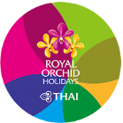
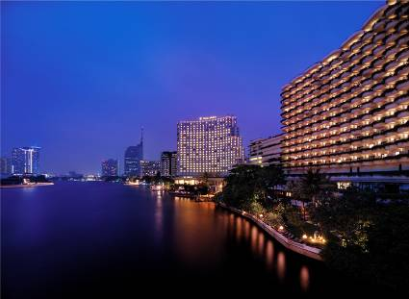
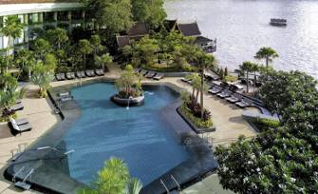
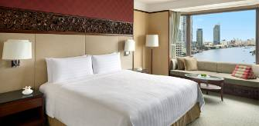

Shangri-La Hotel Bangkok
3 Days 2 Nights Package
https://www.shangri-la.com/bangkok/shangrila/
Validity from 01/5 - 31/10/2020
AC200/EN5.0 Issued: 12/03/2020
Special Offer: (2+1) Stay 3 nights pay 2 nights @ Krungthep River View

Package included: Air ticket + Hotel accommodation with daily breakfast
Room Category | Hotel  Staying period | Package price  <HK$/per person 港幣價目/每位計> |  |  |  |  |  | Extension night with Breakfast
 |  | Adult |  |  | Child |  |  | <HK$/per person 港幣價目/每位計>
 |  | Twin | Single | Ex. Bed | Twin | Ex. Bed | No Bed | Twin | Single | Ex. Bed | No Bed
Deluxe | 01/5  –  31/10/2020 | 3,490 | 5,250 | 2,950 | 3,190 | - | 1,590 | 945 | 1,890 | 648 | 117
Deluxe  River View |  | 3,590 | 5,450 | 2,950 | 3,290 |  |  | 1,004 | 2,007 | 648
Krungthep  River View |  | (2+1) Stay 3 nights pay 2 nights (3rd night included breakfast)
 |  | 3,790 | 5,750 | 2,950 | 3,490 | - | 1,590 | 1,085 | 2,169 | 648 | 117
*Family Offer: Accept 2 children using existing beds in all categories.

Hotel located Chao Phraya River, nearby BTS Saphan Taksin Station,
schedule boat to the famous Shopping mall “ICONSIAM” & “Asiatique”.

Package includes:  - Roundtrip economy class air ticket between Hong Kong and Bangkok by THAI or codeshare flight with THAI Smile.  - 2 Nights hotel accommodation with daily breakfast.  - 0.15% TIC Levy. | 費用包括:  - 泰國國際航空或聯營泰國微笑航空航班來回香港及曼谷  經濟客位機票乙張。  - 2晚酒店住宿連早餐。  - 0.15%旅遊議會印花稅。

Airfare Surcharge 機票附加費:
Departure date | Flight Pattern | Booking Class | Ticket Validity | Surcharge 附加費
出發日期 | 航班 | 訂位 | 機票有效期 | Adult 成人 | Child小童
01/5 - 10/7/20  20/8 - 31/10/20 | RESREVATION & FULL PAY must be  completed before 30 days departure date. | W (AP30) | 2 - 90 Days | Less 100 | Less 70
 | HKG-BKK-HKG  (Any Flight by THAI & THAI Smile) | W (GV1) |  | 0 | 0
 |  | V (GV1) |  | 150 | 110
 |  | K (GV1) | 0 - 1 year | 350 | 260
11/7 - 19/8/20 | RESREVATION & FULL PAY must be  completed before 30 days departure date. | W (AP30) | 2 - 90 Days | 150 | 110
 | HKG-BKK-HKG  (Any Flight by THAI & THAI Smile) | W (GV1) |  | 250 | 190
 |  | V (GV1) |  | 400 | 300
 |  | K (GV1) | 0 - 1 year | 600 | 450
Discount by THAI Smile Flight
01/5 - 10/7/20  20/8 - 31/10/20 | RESREVATION & FULL PAY must be  completed before 30 days departure date. | W (AP30) | 2 - 90 Days | Less 300 | Less 220
 | HKG-BKK-HKG by THAI Smile Flight only  Applicable for TG2630 & TG2631 only | W (GV1) |  | Less 220 | Less 160
 |  | V (GV1) |  | Less 70 | Less 50
11/7 - 19/8/20 | RESREVATION & FULL PAY must be  completed before 30 days departure date. | W (AP30) | 2 - 90 Days | Less 50 | Less 50
 | HKG-BKK-HKG by THAI Smile Flight only  Applicable for TG2630 & TG2631 only | W (GV1) |  | 0 | 0
 |  | V (GV1) |  | 180 | 140
Flight TG2000-2999 are operated by THAI Smile aircrafts, Seat configuration, meal & in-flight services are different from THAI
Remarks:  - Prices quoted are on per person basis and subject to change without prior notice.  - Minimum 2 ADULTS travelling together on the same flight throughout whole journey.  - Flights and room confirmation are subject to availability.  - Package is non-endorsable, non-reroutable and non-refundable.  - Amendment and cancellation is not allowed after the travel document issued.  - Hotel stay must be completed on or before 31 Oct 2020, For hotel stay thereafter, please contact your Travel Agent or THAI Royal Orchid Holidays.  - Departure taxes, Hong Kong airport security charge, airlines insurance surcharge, travel agent service fee and airlines fuel surcharge are not included.  - Deposit payment of HK1,000 per person when making the reservation.  - Full Payment must be pay within 2 working days after the confirmation.  - Reservation is not accepted within 5 working days before departure  - Package is based on Electronic Ticket (E-ticket) & Electronic Tour Voucher (E-Voucher). | 備註:  - 費用均以每人計算，費用如有調整，恕不另行通知。  - 旅程必須最少兩位成人同時出發及同時回程。  - 所有預訂須視乎酒店及機位情況方能確定。  - 旅遊套餐在任何情況下都不能更改，轉讓或退還款項。  - 機票及酒店出票後,將不能更改及取消。  - 酒店住宿必須於2020年10月31日或之前完成。如有任何查詢，請與您的旅遊顧問或皇家風蘭假期聯絡。  - 費用不包括各地機場離境稅，香港機場保安稅，航空公司保險附加費,燃油附加費及旅行社服務費。  - 訂位後, 須繳付訂金每位HK1,000。  - 確定所有訂位後;必須於2個工作天內須繳付所有款項。  - 出發前5個工作天不接受訂購。  - 旅遊套餐只適用於電子機票及電子住房券。

