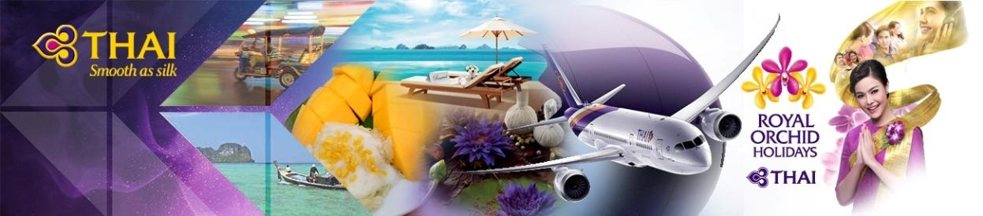

3 Days 2 Nights Phuket Winter Promotion GV2
3天布吉自由行特惠套票
Validity有效日期: 02/1/20 – 31/3/20

THAI Special Promotion
Departure dates: 02/1-22/1, 27/1-30/3
Less HK$250 per Adult, not applicable for child
Sales period: Now till 20/1/20.
For more details, please refer to the air surcharge table.

Air ticket + Hotel accommodation with daily breakfast + Roundtrip transfer between Airport and Hotel +
Added Benefit at the selected hotels.

Code Share flight by THAI Smile Flight
HKG-HKT TG2608 1020/1300
HKT-HKG TG2609 1450/1930
*Schedule for reference only.

AC200/EN5.0 Issued: 20/12/19 |  |  |  | HK$/per person 港幣價目/每位計
Hotel酒店 | Room  Category  房間種類 | Check in date  入住宿日期 | Package Price 套餐價目 |  |  |  |  |  |  | Extension night with Breakfast  延長住宿連早餐
 |  |  | Adult 成人 |  |  |  | Child小童
 |  |  | Twin  佔半房 |  | Single  單人房 | Ex. Bed  加床 | Twin  佔半房 | Ex. Bed  加床 | No Bed  不佔床 | Twin  佔半房 | Single  單人房 | Ex. Bed  加床 | No Bed  不佔床
 | Deluxe | Winter Promotion for 2 nights
Dewa Phuket Resort  Nai Yang Beach  Closed out: 21/12/19 – 03/01/20  https://www.dewaphuketresort.com/ |  | 01/3 – 31/3/20 | 2,890 |  | 3,990 | 2,850 | 2,590 | N/A | 1,690 | N/A | N/A | N/A | N/A
 |  | 04/1 – 29/2/20 | 3,190 |  | 4,550 | 2,850 | 2,990 | N/A | 1,690 | N/A | N/A | N/A | N/A
 |  | Special rate for 3 nights or above
 |  | 01/3 – 31/3/20 | 3,050 |  | 4,350 | 3,250 | 2,750 | N/A | 1,790 | 374 | 747 | 459 | 90
 |  | 04/1 – 29/2/20 | 3,390 |  | 4,990 | 3,250 | 3,090 | N/A | 1,790 | 495 | 990 | 459 | 90
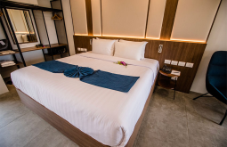
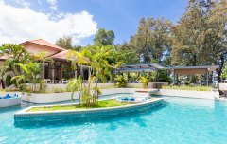
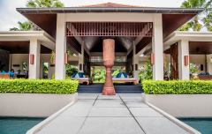

 |  |  |  | HK$/per person 港幣價目/每位計
Hotel酒店 | Room  Category  房間種類 | Check in date  入住宿日期 | Package Price 套餐價目 |  |  |  |  |  |  | Extension night with Breakfast  延長住宿連早餐
 |  |  | Adult 成人 |  |  |  | Child小童
 |  |  | Twin  佔半房 |  | Single  單人房 | Ex. Bed  加床 | Twin  佔半房 | Ex. Bed  加床 | No Bed  不佔床 | Twin  佔半房 | Single  單人房 | Ex. Bed  加床 | No Bed  不佔床
Winter Promotion
Hotel Indigo Phuket Patong  Patong Beach  Closed out: 24/12 – 01/01  https://www.hotelindigo.com | Neighbor  hood | 06/1 – 23/1/20  28/1 – 31/3/20 | 2,990 |  | 4,090 | 2,850 | 2,690 | N/A | 1,790 | 509 | 1,017 | 468 | 117
 |  | 02/1 – 05/1/20  24/1 – 27/1/20 | 3,290 |  | 4,750 | 2,850 | 2,990 | N/A | 1,790 | 662 | 1,323 | 468 | 117
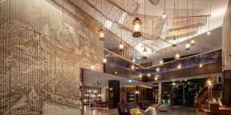
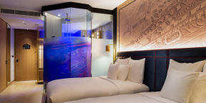
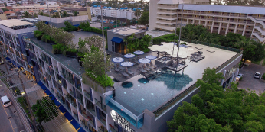

 |  |  |  | HK$/per person 港幣價目/每位計
Hotel酒店 | Room  Category  房間種類 | Check in date  入住宿日期 | Package Price 套餐價目 |  |  |  |  |  |  |  | Extension night with Breakfast  延長住宿連早餐
 |  |  | Adult 成人 |  |  |  | Child小童
 |  |  | Twin  佔半房 |  | Single  單人房 | Ex. Bed  加床 | Twin  佔半房 | Ex. Bed  加床 |  | No Bed  不佔床 | Twin  佔半房 | Single  單人房 | Ex. Bed  加床 | No Bed  不佔床
Winter Promotion
Banyan Tree Phuket  Laguna Beach  Closed out: 24/12 – 07/01 & 21-28/1 & 16-18/3/20  https://www.banyantree.com/en/thailand/phuket | Banyan  Pool Villa | 01/3 - 15/3/20  19/3 – 31/3/20 | 5,090 |  | 8,390 | N/A | 4,790 |  | N/A | 1,890 | 1,670 | 3,339 | N/A | 180
 |  | 08/1 – 20/1/20  29/1 – 28/2/20 | 6,150 |  | 10,490 | N/A | 5,850 |  | N/A | 1,890 | 2,246 | 4,491 | N/A | 180
 | Signature  Pool Villa | 01/3 - 15/3/20  19/3 – 31/3/20 | 5,390 |  | 8,890 | 4,450 | 5,090 |  | N/A | 1,890 | 1,800 | 3,600 | 1,350 | 180
 |  | 08/1 – 20/1/20  29/1 – 28/2/20 | 6,550 |  | 11,190 | 4,450 | 6,150 |  | N/A | 1,890 | 2,430 | 4,860 | 1,350 | 180
 |  | Signature Pool Villa Accepts 2 children for sharing existing bed.
Added Benefits :
~ 20% discount on F&B at any Banyan Tree Phuket operating restaurant including In-Villa Dinning, except Destination Dinning (cannot be applied for Half Board & Full Board supplement charge)
~ 20% discount on Massage at Banyan Tree Spa Phuket (except beauty & facial treatment)
~ 35% discount on golf green fees (publish rate) at Laguna Golf Phuket (except caddy & additional golf cart fees)
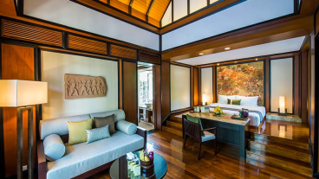
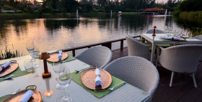
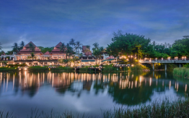

Package includes:  - Roundtrip economy class air ticket between Hong Kong and Phuket (Direct flight ) by THAI <code share with THAI Smile Flight >。  - 2 Nights hotel accommodation with daily breakfast。  - Roundtrip transfer between airport and hotel by seat in coach / van。  - 0.15% TIC Levy。 | 費用包括:  - 泰國國際航空直航來回香港及布吉經濟客位機票乙張。  <聯營航班~由泰國微笑航空營運>  - 2晚酒店住宿連早餐。  - 布吉機場及酒店來回接送。  - 0.15%旅遊議會印花稅。

Airfare Surcharge 機票附加費:
Departure date | Flight Pattern | Booking Class | Ticket Validity | Surcharge 附加費
出發日期 | 航班 | 訂位 | 機票有效期 | Adult 成人 | Child小童
THAI Special Discount <ticket issuance on or before 20 Jan 2020>
02/1/20 - 22/1/20,  27/1/20 - 30/3/20 | HKG-HKT-HKG TG2608 & TG2609 only  Operated by THAI Smile aircrafts | W (GV1) | 2 - 14 Days | Less 250 | 110
 |  | V (GV1) |  | Less 50 | 320
02/1/20 - 22/1/20,  27/1/20 - 30/3/20 | RESREVATION & FULL PAY must be  completed before 30 days of departure date | W (AP30) | 2-90 Days | Less 100 | Less 70
 | HKG-HKT-HKG TG2608 & TG2609 only  Operated by THAI Smile aircrafts | W (GV1) |  | 0 | 0
 |  | V (GV1) |  | 150 | 110
 |  | K (GV1) | 0-1 year | 350 | 260
23/1 - 26/1/20 |  | K (GV1) |  | 850 | 640
 |  | T (GV1) |  | 1070 | 800
 |  | Q (GV1) |  | 1340 | 1010
Flight TG2000-2999 are operated by THAI Smile aircrafts, Seat configuration, meal & in-flight services are different from THAI
Thai Airways Baggage Policy, please refer to the below web page
https://www.thaiairways.com/en/plan/travel_information/baggage.page?

Remarks:  - Prices quoted are on per person basis and subject to change without prior notice.  - Minimum 2 ADULTS travelling together on the same flight throughout whole journey.  - Flights and room confirmation are subject to availability.  - Package is non-endorsable, non-reroutable and non-refundable.  - Amendment and cancellation is not allowed after the travel document issued.  - Hotel stay must be completed on or before 31 Mar 2020, For hotel stay thereafter, please contact your Travel Agent or THAI Royal Orchid Holidays.  - Departure taxes, Hong Kong airport security charge, airlines insurance surcharge, travel agent service fee and airlines fuel surcharge are not included.  - Deposit payment of HK1,000 per person when making the reservation.  - Full Payment must be pay within 2 working days after the confirmation.  - Reservation is not accepted within 5 working days before departure  - Package is based on Electronic Ticket (E-ticket) & Electronic Tour Voucher  (E – Voucher). | 備註:  - 費用均以每人計算，費用如有調整，恕不另行通知。  - 旅程最少兩位成人同時出發及同時回程。  - 所有預訂須視乎酒店及機位情況方能確定。  - 旅遊套餐在任何情況下都不能更改，轉讓或退還款項。  - 機票及酒店出票後,將不能更改及取消。  - 酒店住宿必須於2020年3月31日或之前完成。如有任何查詢，請與您的旅遊顧問或皇家風蘭假期聯絡。  - 費用不包括各地機場離境稅，香港機場保安稅，航空公司保險附加費,燃油附加費及旅行社服務費。  - 訂位後, 須繳付訂金每位HK1,000。  - 確定所有訂位後;必須於2個工作天內須繳付所有款項。  - 出發前5個工作天不接受訂購。  - 旅遊套餐只適用於使用電子機票及電子住房劵。

