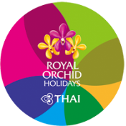
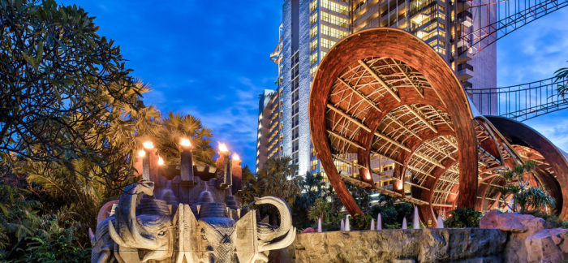
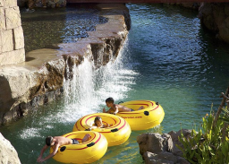
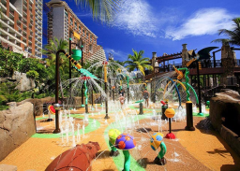

AC200/EN5.0 Issued: 17/3/2020
Package included: Air ticket + 2 Nights hotel stay with daily breakfast + Roundtrip transfer between
Airport and hotel.
3 Days 2 Nights Pattaya GV2
Centara Grand Mirage Beach Resort
Website: https://www.centarahotelsresorts.com/centaragrand/cmbr
Validity from 01/5 - 31/10/2020

Centara Grand Mirage Beach Resort Pattaya is an exciting themed five-star resort that is a destination in its own right, an entire world of pleasure, a place where everyday cares are laid aside and where everyone will find something to amaze and delight. A scheduled shuttle service connects to Central Festival Pattaya shopping and lifestyle centre on an hourly basis.
Room Category | Hotel  Staying period | Package price  <HK$/per person 港幣價目/每位計> |  |  |  |  |  | Extension night with Breakfast
 |  | Adult |  |  | Child |  |  | <HK$/per person 港幣價目/每位計>
 |  | Twin | Single | Ex. Bed | Twin | Ex. Bed | No Bed | Twin | Single | Ex. Bed | No Bed
Early Bird offer: 30 Days booking in advance
Deluxe Ocean Facing | 01/5 – 10/7/20  24/8 – 31/10/20 | 3,590 | 5,250 | 3,290 | 3,290 | N/A | 1,990 | 581 | 1,161 | 540 | No extra cost basis
Deluxe Family Ocean Facing |  | 3,690 | 5,490 | N/A | 3,390 | N/A | 1,990 | 644 | 1,287 | N/A
Premium Deluxe  Ocean Facing |  | 3,750 | 5,650 | 3,290 | 3,450 | N/A | 1,990 | 680 | 1,359 | 540
Deluxe Ocean Facing | 11/7 – 23/8/20 | 3,850 | 5,790 | 3,290 | 3,550 | N/A | 1,990 | 729 | 1,458 | 540
Deluxe Family Ocean Facing |  | 3,950 | 6,050 | N/A | 3,650 | N/A | 1,990 | 792 | 1,584 | N/A
Premium Deluxe  Ocean Facing |  | 4,050 | 6,190 | 3,290 | 3,750 | N/A | 1,990 | 828 | 1,656 | 540
Deluxe Ocean Facing & Premium Deluxe Ocean Facing for 3 persons.
Deluxe Family Ocean Facing – Twin bed, accept 2 children in one room.

Room Category | Hotel  Staying period | Package price  <HK$/per person 港幣價目/每位計> |  |  |  |  |  | Extension night with Breakfast
 |  | Adult |  |  | Child |  |  | <HK$/per person 港幣價目/每位計>
 |  | Twin | Single | Ex. Bed | Twin | Ex. Bed | No Bed | Twin | Single | Ex. Bed | No Bed
Deluxe Ocean Facing | 01/5 – 10/7/20  24/8 – 31/10/20 | 3,750 | 5,650 | 3,290 | 3,450 | N/A | 1,990 | 684 | 1,368 | 540 | No extra cost basis
Deluxe Family Ocean Facing |  | 3,890 | 5,950 | N/A | 3,550 | N/A | 1,990 | 761 | 1,521 | N/A
Premium Deluxe  Ocean Facing |  | 3,950 | 6,050 | 3,290 | 3,650 | N/A | 1,990 | 801 | 1,602 | 540
Deluxe Ocean Facing | 11/7 – 23/8/20 | 4,090 | 6,290 | 3,290 | 3,790 | N/A | 1,990 | 860 | 1,719 | 540
Deluxe Family Ocean Facing |  | 4,190 | 6,550 | N/A | 3,890 | N/A | 1,990 | 932 | 1,863 | N/A
Premium Deluxe  Ocean Facing |  | 4,290 | 6,690 | 3,290 | 3,990 | N/A | 1,990 | 977 | 1,953 | 540
Deluxe Ocean Facing & Premium Deluxe Ocean Facing for 3 persons.
Deluxe Family Ocean Facing – Twin bed, accept 2 children in one room.

Package includes:  - Roundtrip economy class air ticket between Hong Kong and  Bangkok by THAI.  - 2 Nights hotel accommodation with daily breakfast.  - Roundtrip PRIVATE CAR transfer between Bangkok airport and hotel in Pattaya  - 0.15% TIC Levy. | 費用包括:  - 泰國國際航空來回香港及曼谷經濟客位機票乙張。  - 2晚酒店住宿連早餐。  - 曼谷機場及芭堤雅酒店私家車來回。  - 0.15%旅遊議會印花稅。

Airfare Surcharge 機票附加費:
Departure date | Flight Pattern | Booking Class | Ticket Validity | Surcharge 附加費
出發日期 | 航班 | 訂位 | 機票有效期 | Adult 成人 | Child小童
01/5 - 10/7/20  20/8 - 31/10/20 | RESREVATION & FULL PAY must be  completed before 30 days departure date. | W (AP30) | 2 - 90 Days | Less 100 | Less 70
 | HKG-BKK-HKG  (Any Flight by THAI & THAI Smile) | W (GV1) |  | 0 | 0
 |  | V (GV1) |  | 150 | 110
 |  | K (GV1) | 0 - 1 year | 350 | 260
11/7 - 19/8/20 | RESREVATION & FULL PAY must be  completed before 30 days departure date. | W (AP30) | 2 - 90 Days | 150 | 110
 | HKG-BKK-HKG  (Any Flight by THAI & THAI Smile) | W (GV1) |  | 250 | 190
 |  | V (GV1) |  | 400 | 300
 |  | K (GV1) | 0 - 1 year | 600 | 450
Discount by THAI Smile Flight
01/5 - 10/7/20  20/8 - 31/10/20 | RESREVATION & FULL PAY must be  completed before 30 days departure date. | W (AP30) | 2 - 90 Days | Less 300 | Less 220
 | HKG-BKK-HKG by THAI Smile Flight only  Applicable for TG2630 & TG2631 only | W (GV1) |  | Less 220 | Less 160
 |  | V (GV1) |  | Less 70 | Less 50
11/7 - 19/8/20 | RESREVATION & FULL PAY must be  completed before 30 days departure date. | W (AP30) | 2 - 90 Days | Less 50 | Less 50
 | HKG-BKK-HKG by THAI Smile Flight only  Applicable for TG2630 & TG2631 only | W (GV1) |  | 0 | 0
 |  | V (GV1) |  | 180 | 140
Flight TG2000-2999 are operated by THAI Smile aircrafts, Seat configuration, meal & in-flight services are different from THAI

Remarks:  - Prices quoted are on per person basis and subject to change without prior notice.  - Minimum 2 ADULTS travelling together on the same flight throughout whole journey.  - Flights and room confirmation are subject to availability.  - Package is non-endorsable, non-reroutable and non-refundable.  - Amendment and cancellation is not allowed after the travel document issued.  - Hotel stay must be completed on or before 31 Oct 2020, For hotel stay thereafter, please contact your Travel Agent or THAI Royal Orchid Holidays.  - Departure taxes, Hong Kong airport security charge, airlines insurance surcharge, travel agent service fee and airlines fuel surcharge are not included.  - Deposit payment of HK1,000 per person when making the reservation.  - Full Payment must be pay within 2 working days after the confirmation.  - Reservation is not accepted within 5 working days before departure  - Package is based on Electronic Ticket (E-ticket) & Electronic Tour Voucher  (E – Voucher). | 備註:  - 費用均以每人計算，費用如有調整，恕不另行通知。  - 旅程必須最少兩位成人同時出發及同時回程。  - 所有預訂須視乎酒店及機位情況方能確定。  - 旅遊套餐在任何情況下都不能更改，轉讓或退還款項。  - 機票及酒店出票後,將不能更改及取消。  - 酒店住宿必須於2020年10月31日或之前完成。如有任何查詢，請與您的旅遊顧問或皇家風蘭假期聯絡。  - 費用不包括各地機場離境稅，香港機場保安稅，航空公司保險附加費,燃油附加費及旅行社服務費。  - 訂位後, 須繳付訂金每位HK1,000。  - 確定所有訂位後;必須於2個工作天內須繳付所有款項。  - 出發前5個工作天不接受訂購。  - 旅遊套餐只適用於使用電子機票及電子住房劵。

